Date : 22-09- 2022
Organised by : Department of Botany
Theme/Objective : To raise knowledge about An Awareness Programme Is Ozone Hole Shrinking?
Resource Person : II M.Sc Botany Students, Holy Cross College (Autonomous), Nagercoil
Outcome of the Activity: To got awareness on ozone hole shrinking
No. of Beneficiaries : 71
Venue : St. Joseph’s Hall
Report :
Ozone Day, or International Day for the Preservation of the Ozone Layer, is observed every year on 16th September. Ozone day is celebrated to raise ozone depletion awareness and highlight its importance. To commemorate this day department of Botany organized an awareness programme Is Ozone Hole Shrinking?. The programme was conducted on 22- 09-2022 by II M.Sc Botany students who comprises the Ozone hole and the healing of the ozone layer and spreads the world about the need to protect it.
Brochure
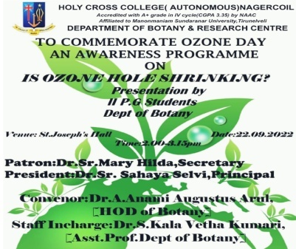

Photos

